Chapter 7 AKS2L Series Hot Melt Adhesive Machine
7.1 AKS2L Series Hot Melt Adhesive Machine System Introduction
The AKS2L series hot melt adhesive machine uses temperature controllers to regulate each zone. The system is intuitive, simple, and easy to maintain.
The AKS2L series uses sequential heating control. Upon cold start, the main melting tank and hose/gun temperature controllers energize simultaneously. The system reaches ready temperature in approximately 0.2 hours. Once all zones reach set temperature, operation may begin.

AKS2L Series Hot Melt Adhesive Machine Control Panel
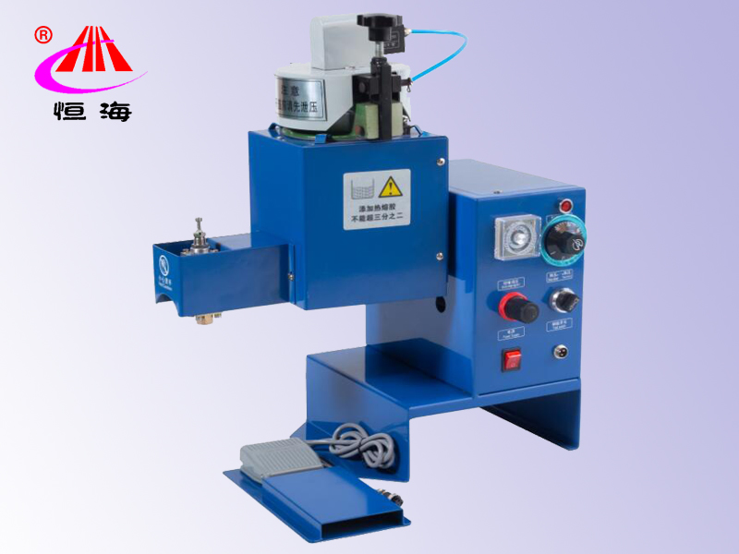
Each temperature controller corresponds to one independent heating zone with individually settable temperature.
7.2 AKS2L Series Hot Melt Adhesive Machine Parameters:
Power Supply: 220VAC/50Hz
Installed Power: 1800W
Tank Capacity: 2L
Melting Rate: 2L/h
Applicable Adhesive Viscosity: 200-4000 cP
Operating Temperature: Max 220C
Compressed Air: >0.7MPa
Output Port: 1
Dimensions: 460x330x580 (LxWxH)
7.3 AKS2L Series Hot Melt Adhesive Machine Operating Procedure
The machine uses PID temperature control matched to hot melt adhesive characteristics. The melter has a built-in dispensing head; temperature settings control 2 heating zones. The control terminal automatically alarms and alerts for operator errors and faults. The machine precisely controls the temperatures of the melting tank and dispensing head.
The AKS2L uses compressed air to dispense melted adhesive to the dispensing head. Output pressure is adjusted by input air pressure. The machine is equipped with a footswitch; when the footswitch is pressed, the dispensing valve opens and adhesive flows.
The Teflon-treated melting tank accommodates hot melt adhesives in pellet, granular, and block form. The tank section
has a glue pressure gauge and heating fins available as options.

Startup Procedure
1. Connect the air supply to the regulator input port. Adjust the regulator to set input air pressure to 0.6MPa. Plug the machine power cord into a 220VAC outlet.
2. Ensure the air filter/regulator switch on the control panel is in the vent position. Unscrew the locking bolt on top of the tank lid, add clean hot melt adhesive to the tank, clear any adhesive from the tank rim, then immediately close and lock the lid to prevent contamination.
3. Turn on the main power switch on the control panel. The temperature controller indicator lights up. Set the controller to 165C and the machine begins heating.
4. Wait for warm-up (approx. 20-30 minutes) until adhesive is melted and all zone temperatures are stable.
5. After temperature is reached, set the air filter/regulator switch on the control panel to the pressurized position. Operation may begin.
6. Press the footswitch; adhesive flows from the dispensing nozzle. Flow rate is controlled by the adjustment bolt on top of the nozzle: turn counterclockwise to increase flow, clockwise to decrease.
7. When adding adhesive during operation, first close the air supply or set the panel switch to vent position before opening the lid.
8. To shut down, first close the air supply, then turn off the power.

7.4 AKS2L Series Hot Melt Adhesive Machine Tank Structure Diagram
